13.Perform Affine Transformation on the given image using python and Open CV.

**AIM:**

To perform an Affine Transformation on a given image using Python and OpenCV.

**PROCEDURE:**

1. Install OpenCV if not already installed using:

1. Import the cv2 and numpy modules.
2. Read the input image using cv2.imread().
3. Define three points from the original image and their corresponding locations in the transformed image.
4. Compute the Affine Transformation matrix using cv2.getAffineTransform().
5. Apply the transformation using cv2.warpAffine().
6. Display the original and transformed images using cv2.imshow().
7. Save the transformed image using cv2.imwrite(), if needed.
8. Wait for a key press and close all image windows using cv2.waitKey(0) and cv2.destroyAllWindows().

**PROGRAM:**

import cv2

import numpy as np

image = cv2.imread("image.jpg")

rows, cols, ch = image.shape

pts1 = np.float32([[50, 50], [200, 50], [50, 200]])

pts2 = np.float32([[10, 100], [200, 50], [100, 250]])

matrix = cv2.getAffineTransform(pts1, pts2)

transformed_image = cv2.warpAffine(image, matrix, (cols, rows))

cv2.imshow("Original Image", image)

cv2.imshow("Affine Transformed Image", transformed_image)

cv2.imwrite("affine_transformed.jpg", transformed_image)

cv2.waitKey(0)

cv2.destroyAllWindows()

**INPUT:**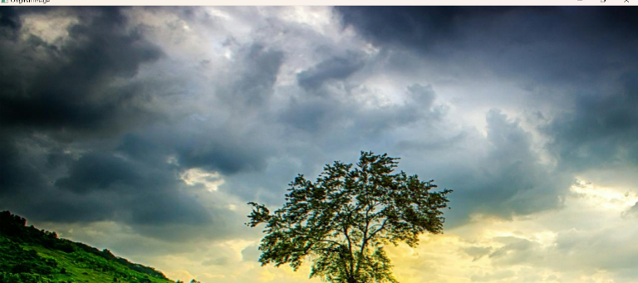

**OUTPUT:**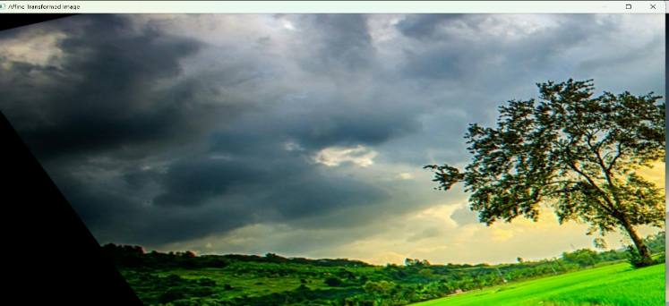

**RESULT :**

The program successfully applies an Affine Transformation to the given image, displays it, and saves it as "affine_transformed.jpg".